In my example I actually created a Service Category called LKQ Parts then created a Service Package under that Service Category called LKQ Parts with just a blank (shows “Description”) material line item and added to a work order. (Note: You can always add a material line to an existing Service Package)

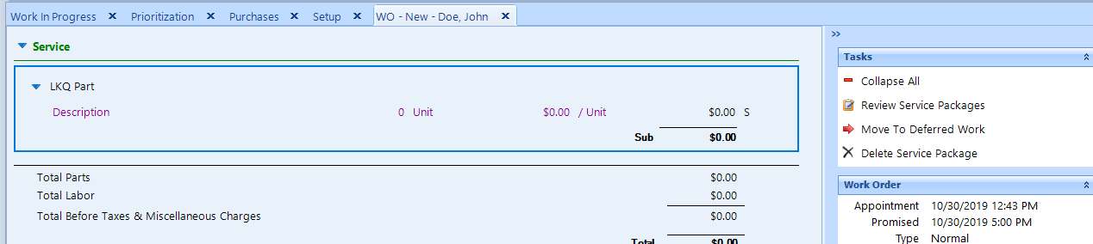

Double click to open the material line item – Update Description | changed Price Level to Fixed Total | Enter Qty | Enter price to invoice at in “Total” field and leave Unit Cost to $0.00 (see below)
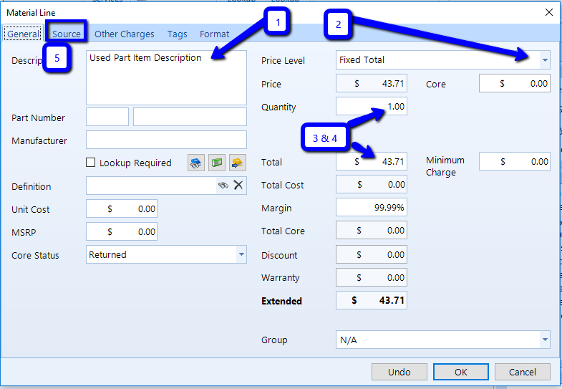
Click on the Source Tab | Change to Receive item and add part number (optional )| Select Supplier | Select or add Supplier Invoice number | Click Ok (NO NEED TO DO ANYTHING WITH PRICE)
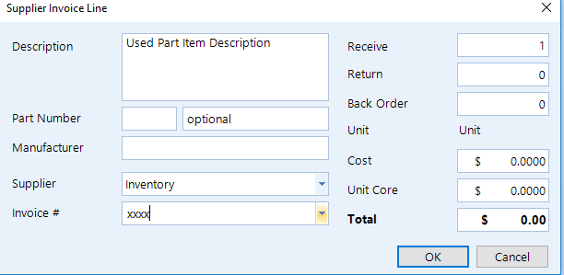
When you click Ok you will see message prompt appear “There is no pricing for this line. Are you sure you want to continue?” Click Yes | another message prompt will appear “The total for this line is zero. Are you sure you want to continue? } Click Yes | Click OK.

The line item on the work order is black because it has been sourced and a $0.00 Supplier Invoice has been created to post to the payable.

