Entering Payroll from a Spreadsheet
Please note my examples below are all done in a multi-location environment using the intercompany holding account
(Transactions To/From Other Locations) and an Enterprise Bank. You may use your own account numbers keeping them consistent across locations.

To enter your third party payroll from a spreadsheet you must first create account numbers for each of the ledger accounts that you will be using because this is how the system will know where to put the entries. (See example in image below)
To do this go to Setup from the home ribbon | type Ledger in the search field | Select Ledger Accounts from the left panel | Double click to open Ledger Account and enter an Account Number. Please keep in mind this must be consistent across all locations.
Next you will create a spreadsheet see below for your column header (Account Name) options:
- Date
- Account Number
- Description
- Debit Amount
- Credit Amount
- Amount
Note: You will need to go in the column for the Date and Debit, Credit or Amount column and format cells as follows:
Right click in the Date Column | Format Cells | Under the Number tab select Date | and choose either 03/14/01 or 3/14/01 under type | Click Ok
Right click in the Debit, Creditor Amount column | under the Number tab select Currency | Click Ok
(See images below)
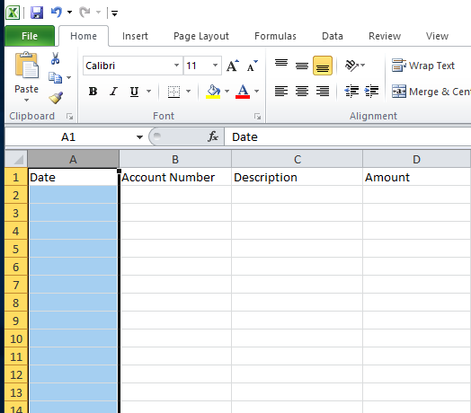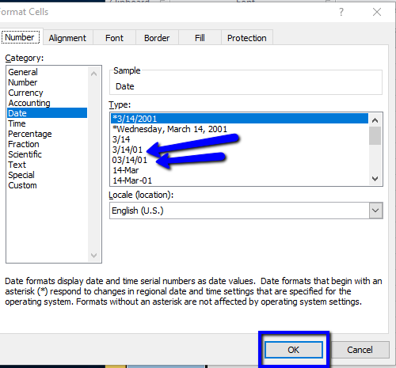
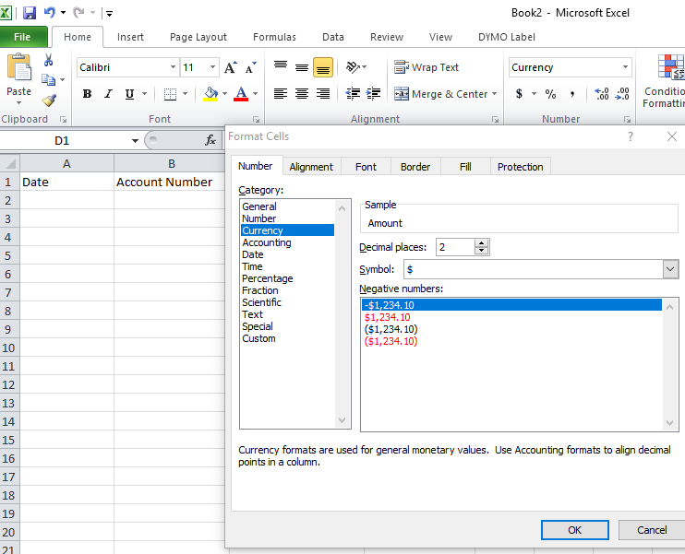
Enter the data on the spreadsheet | Please note for the negative entries you must enter with a minus sign in front of the amount as system did not like parenthesis.
Important: You MUST SAVE AS A File extension CSV(Comma Delimited) | Save payroll spreadsheet to a location on your hard drive easy to locate ( desktop recommended) | Close the spreadsheet.
Go to the General Ledger on the Home Ribbon | Select Import on the ribbon | Click the drop down arrow under Import Format to elect Generic Ledger Transaction Import | Click Next | Important: You must change the file extension to CSV(Comma Delimited)(*.txt) to CSV(Comma Delimited)(*.csv) | Browse for the spreadsheet you saved to a location on your hard drive | Leave Delimiter set to Comma | Leave box checked for First Row is Header | Map each column accordingly | Click Next | Click Close.
(See image below)
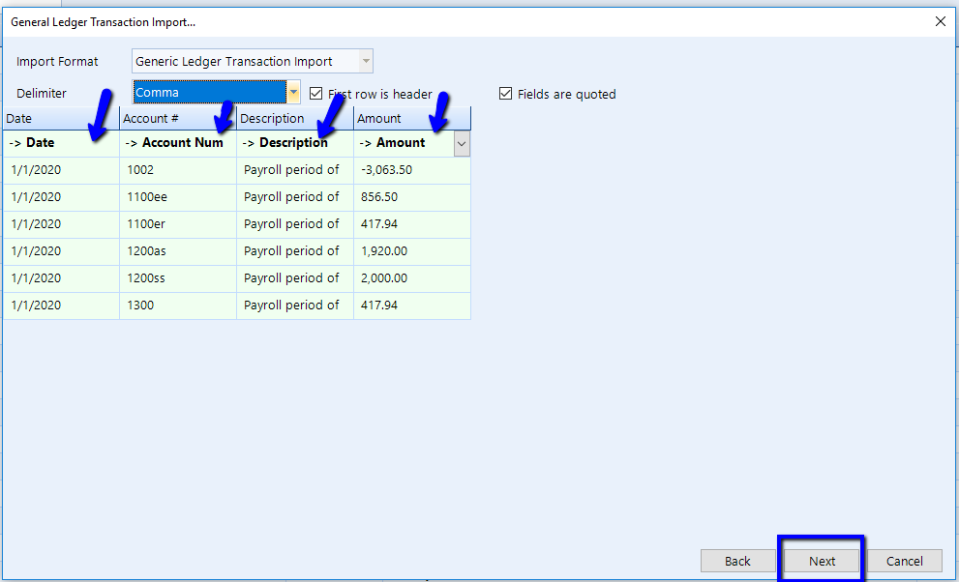
Please note when you are doing this for an Enterprise Setup using the Transactions To/From Other Locations account you will need to do the Entries at the Enterprise location with a Debit to the Transactions To/From Other Locations and the Credit will be the Enterprise Bank if applicable.
There are going to be many variations regarding the shop’s preference in how detailed the shop wants to see the payroll (i.e. for each employee, lump sum for each payroll account, shop pays taxes, third party pays taxes and whether or not to include the payroll processing fees if applicable)

